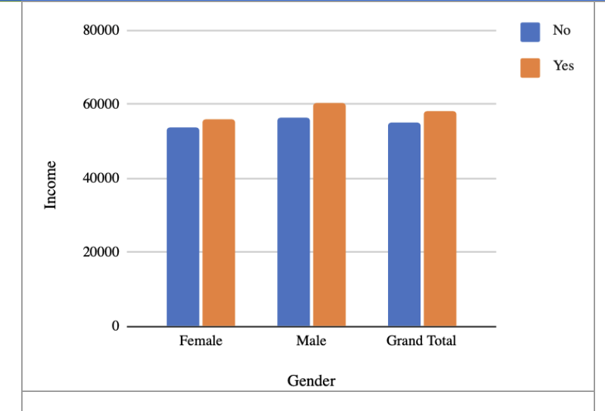

Key Insights from the Chart (Gender vs Income vs Loan Approval “Yes/No”)
This chart compares average income across gender (Male/Female) and whether individuals were approved (Yes) or not approved (No) for a loan or similar evaluation.

1. Income Levels Are Higher for Approved (“Yes”) Applicants
- For both genders, the “Yes” category shows higher income compared to the “No” category.
- Approximate values:
  - Female: No ≈ 53,000 | Yes ≈ 55,000
  - Male: No ≈ 56,000 | Yes ≈ 60,000
Insight: Higher income is closely associated with approval. Income is likely a major factor in the decision-making process.

2. Males Have Slightly Higher Income Than Females
- In both the “Yes” and “No” categories, males earn slightly more on average.
- Male No ≈ 56k vs Female No ≈ 53k
- Male Yes ≈ 60k vs Female Yes ≈ 55k
Insight: There is a small gender income gap, with males earning somewhat more in this dataset.

3. The Approval Gap Is Larger for Males
- The difference between No and Yes is bigger for males (around +4k) compared to females (around +2k).
Insight: Income appears to have an even stronger influence on approval decisions for male applicants.

4. Overall (Grand Total)
- The same pattern continues at the total level: income for approved applicants is higher than for non-approved applicants.
Insight: Approval strongly correlates with income regardless of gender.

5. Interpretation in a Lending or Financial Context
If this chart represents loan approvals:
- Higher-income applicants are more likely to be approved.
- Gender does not significantly alter the approval pattern.
- The decision process is largely income-driven, not gender-driven.

Conclusion (Interview-Ready):
“This chart shows that income is a key factor influencing approval decisions. For both males and females, higher-income individuals are more likely to be approved. While males have slightly higher incomes overall, the approval pattern remains consistent across genders, indicating that the process is driven primarily by income rather than gender.”

